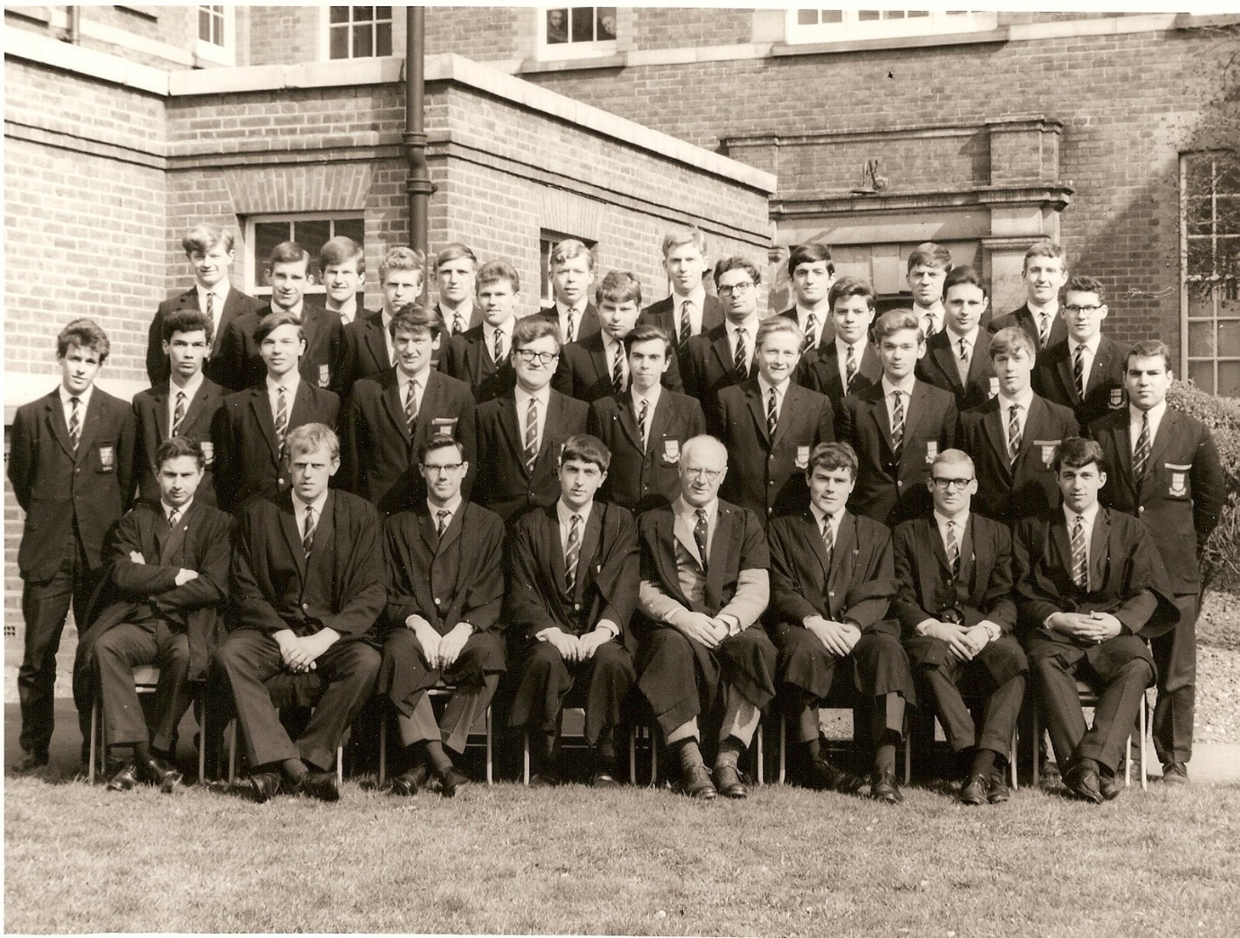
With Mr Ackland.

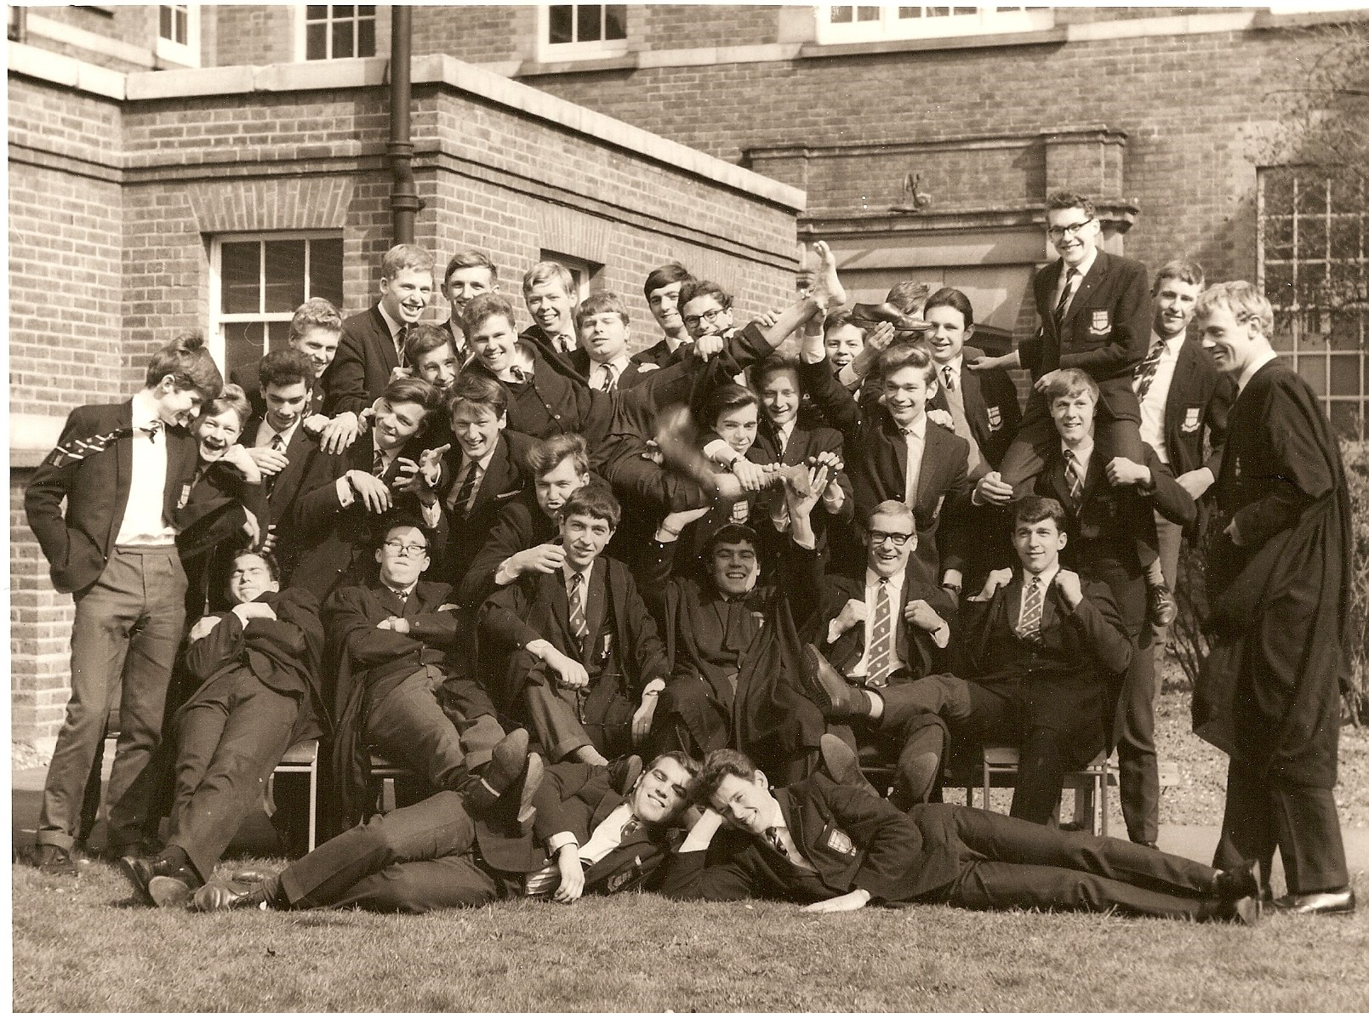
Without Mr Ackland!

PREFECTS 1964-65
Photos provided by Mike Hobbs

Back row – 6th from left - Michael Hobbs Middle row – 4th from right - Peter Scull
Front row – LEFT TO RIGHT – Not known – May – Harry King – Chris Fifield (Head Boy) Mr Ackland – Peter Lane – Not known – Not known
In the lower photograph Michael is left middle with a waistcoat and his legs in the air!!!

If you can add names to this photo please let us know.

