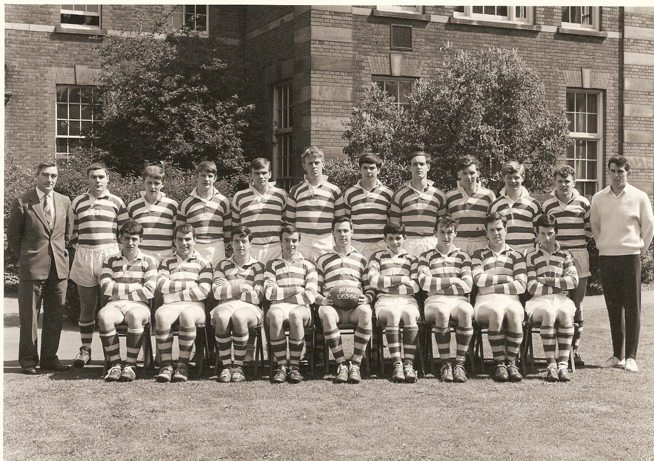
RUGBY 1st XV 1963-64
Photo provided by Mike Hobbs

Back Row – LEFT TO RIGHT - Staff (Mr H R Hore) – Peter Lane – Yaxley – Peter Morgan – Peter Budden – May – Templeton – David Poupart – Keith Ford – Mick Farrow – MICHAEL HOBBS – Member of Staff (Mr Tucker?)
Front Row – LEFT TO RIGHT - Not known – Not known – Peter Cook – Not known – Harry King (Captain) – Not known – Not known – Peter Jeffery – Not known

If you can add names to this photo please let us know.

