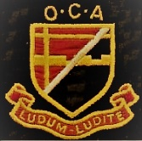
THE OLD CROYDONIANS' ASSOCIATION
MINUTES OF THE ANNUAL GENERAL MEETING 2019
Held on Saturday, 20th July, 2019: 3.00pm at The BRIT School, The Crescent, Croydon
1. RIPs and Apologies for Absence
(a) The Chairman welcomed those attending and invited all to stand for one minute’s silence in memory of those members and other former members of the school and staff whose death had been notified to us since the last AGM: Tom ALCROFT (Staff 1957-87), Michael CRISP 1960-67, Derek CROKER 1940-45, David ENDACOTT 1942-46; Robert FITSAL 1941-47, Margaret FREEMAN (Staff 1954-1988);,Janice KAY née Willett 1943-49;,Alasdair MANSFIELD 1960-67, Alec NEW 1941-46, Sue RAMSDALE née Baines (1955-60), Oliver James Richard ("Dick") BISSET 1933-40(?), Peter A SMITH 1969-(?), Helen SPRATLEY née Gostling 1936-44, Heather VICKERY née Stockley 1940-47, John WILKINS 1951-58.

(b) The Chairman noted apologies for absence from: George ANDRONOV, John ASHE, Les and Heather BRATT,
Robin CHASE, Hazel DAMIRAL née Dennis, Brian FLATMAN, Ken HARMAN, Roger HILL, Steve PALMER, Sue PEARL née Roer, Brian SELF. Austen SHAPCOTT, Elizabeth VEASEY, Graham WARDEN and
Gwyneth WEIR née Rose.

2. The Minutes of the AGM held on Saturday 28th July 2018 were accepted without comment, the motion being proposed by Derek MAURI and seconded by John COOK and passed unanimously. There were no matters arising not covered in other Agenda items.

3. Report from the Chairman & Webmaster - Cortland Fransella
Chairman’s Report.
- Another successful year of events providing opportunities for OCA members to meet and to catch up with memories of Selhurst and beyond.
- Good relations with the BRIT School (former Girls’ School) and with the Crescent Primary School (former Boys’ School). The change of status to academy by the primary school should not affect our relationship. For the second year running we gave £200 towards gifts for primary leavers.
- Another excellent edition of the magazine depends, as with all the work of the Committee, on volunteers generous with their time and talents. We need more volunteers to lighten the load.
- We were glad to welcome two new Committee Members – Caroline Stoneman née Presnail and Sue Pearl née Roer.
- Membership and finances are holding up but it would be good if more would pay the modest £12 annual subscription.
- Thanks to John Cook for examining our accounts.
Webmaster’s Report.
- The statistics below show continued high interest in the website.
- A number of new contacts have come from people finding our website.
- If you think material from the old website is missing, please contact the webmaster.
- New items for the website, as for the magazine, are always welcome.
- Only sustaining members paying the annual subscription have access to password-protected material on the website.
- If someone would like to assist with maintenance of the website, that would be very welcome.

Website Statistics:
Page Impressions
Referring Websites

 | August  2018 | September  2018 | October  2018 | November  2018 | December  2018 | January  2019 | February  2019 | March  2019 | April  2019 | May  2019 | June  2019 | July  2019

Month | Page Impressions | Referring Websites
[15] July 2019 | 7101 | 3
June 2019 | 12205 | 6
May 2019 | 12297 | 3
April 2019 | 15245 | 1
March 2019 | 13737 | 1
February 2019 | 14308 | 2
January 2019 | 14811 | 2
December 2018 | 12570 | 1
November 2018 | 12430 | 1
October 2018 | 13346 | 5
September 2018 | 18882 | 5
August 2018 | 19367 | 5

Definitions

Page Impression
Every time that a page is viewed on the site it generates 1 page impression. So, if someone viewed 5 pages, this would create 5 page impressions.
Referring Websites
This is the number of times that a visitor has clicked on another website link to reach our site (ie from a Google.com search).

4. Presentation of 2018-2019 accounts & report by Treasurer – Mike Cuming
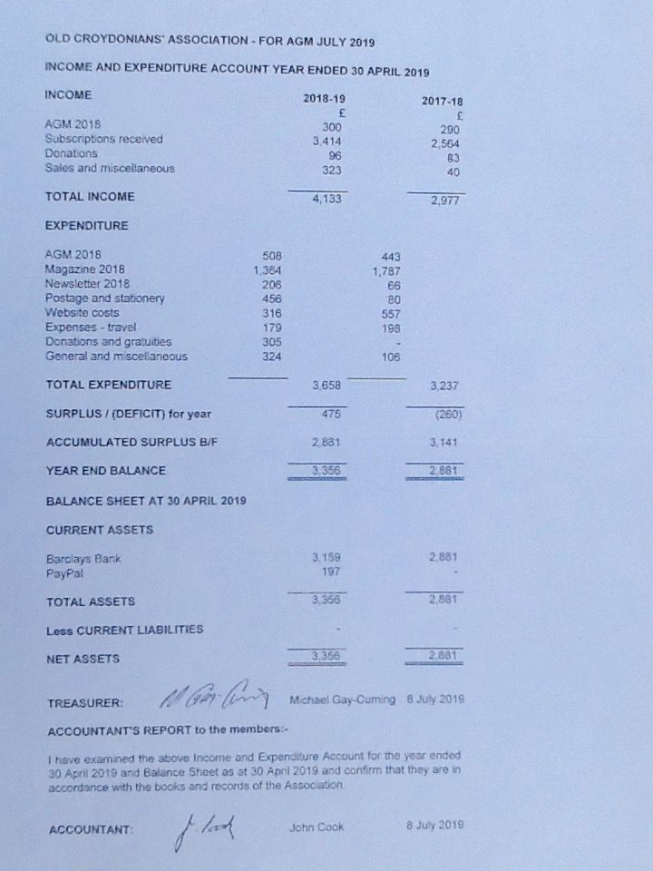

5. Membership Secretary's report – Michael Keitch
- Total registered Membership as at 09 July 2019
  - Boys 329
  - Girls 133
  - Staff 9 (including one who was also a pupil)
Total 471 which includes 7 joint couples
- Sustaining Members paying an annual subscription of £12 for 2018/19 = 248
- Changes in Membership:
  - Deceased 12
  - Resigned 8
  - New Members 19
6. Report from the Magazine Editors - Valerie Heathorn, Brian Young & Roger Hill
1. The 2019 Magazine was the 3rd under the new editorship team and our biggest edition so far, including more pages in colour. We hope everyone enjoyed reading it.

2. Longer versions of some of the articles are available to read on the website.

3. Thanks to all our contributors who helped to make it a bumper issue. We always welcome feedback and comments.

4. Apologies for the late publication caused by many factors, mainly through incorporating last minute changes at the printing stage.

5. We had excellent collaboration with The Crescent Primary School which allowed us to use the photographs of current pupils.

6. We are now open for articles for the 2020 edition. The deadline is 31st December 2019. All copy to be addressed to the Editor, details below.

7. Members’ subscriptions (£12 pa) make the magazine possible. Only subscribing members are entitled to receive it: please try to persuade any friend who is not currently a subscribing member to become one in 2019/20 (subscriptions due this September).

8. The next annual Autumn Newsletter is due out in September and will include information about future outings, a subscription reminder, feedback from the AGM, a membership update and the latest news about OCA matters.

Address for contributions: Valerie Heathorn Editor@theoldcroydonians.org.uk

Tony Teal expressed his appreciation of the quality of the 2019 magazine, which he regarded as better than any similar product which he had seen. Congratulations were expressed to the magazine team by all present.

7. Report on Events from the Master of the Revels – Bob Smith
- We have held the following events in the past twelve months:
- Annual Reunion 28 July 2018, attended by 38 people.
- Lunchtime outing to the Sky Garden 17 October 2018, attended by 23 people
- Remembrance Event at The Crescent School 09 November 2018, attended by 8 people
- Informal Social at Parcel Yard 10 November 2018, attended by 22 people
- Visit to the aircraft carrier HMS Queen Elizabeth 23 March 2019, attended by 16 people
- Visit to the Old Palace School, Croydon 12 April 2019, attended by 17 people
2. Planned Events:
Confirmed:
- The Crescent Primary School Leavers' Ceremony 23 July 2019
- Royal Hospital Chelsea 08 October 2019
- Remembrance Event at The Crescent Primary School 08 November 2019
- Informal Social at the Parcel Yard, King’s Cross 23 November 2019
To be confirmed:
- Spring outing 2020
- Autumn outing 2020
- Spring outing 2021
- Autumn outing 2021

Note:
We started some of these more 'social' events a few years ago with the aim of providing an opportunity for members to meet up in an informal way. We have now established a pattern of two such outings a year, one in the spring and one in the autumn. The numbers show that they remain popular occasions, and have been instrumental in rekindling many past friendships, which is an added bonus. We aim, when possible, to find venues with a Selhurst or Croydon connection, but will consider anywhere likely to interest members. At the moment for the 'tbc' events we are thinking of possibly Lambeth Palace, the newly refurbished Fairfield Halls or maybe a return visit to the Tower of London. Suggestions are always welcome to bob.smith@theoldcroydonians.org.uk .

8. Adoption of the Reports
Tony Teal proposed that all the reports should be adopted, with Graham Derriman seconding. The motion was passed unanimously.
9. Election of Committee for 2019-2020 & Honorary Auditor
There being no new candidates to serve on the Committee, and all the current members being willing to continue, the following were duly re-elected:
Richard CHATTERJEE – without portfolio

Mike CUMING – Treasurer

Cortland FRANSELLA – Chairman, Secretary and Webmaster

Valerie HEATHORN – Vice-Chair and Magazine Editor

Roger HILL – Magazine Support

Michael KEITCH – Membership Secretary

Sue PEARL – without Portfolio

Bob SMITH – Master of the Revels

Caroline STONEMAN – without Portfolio

Brian YOUNG – Magazine support

Margaret ZIOLEK – Remembrance liaison

John COOK had kindly agreed to check the accounts and to be re-appointed in that capacity as our honorary ‘Auditor’.

10. Thanks to Lesley Ryan.
The Committee and all present expressed their thanks to Lesley Ryan for once again providing an excellent buffet. At her request, in place of the usual bouquet of flowers, we agreed to make a donation to the charity Lendwithcare, which provides microfinance in the developing world.

11. Any other business.
There being no other business, the meeting concluded at 3.15pm.

